UiPath Document Understanding (Modern Projects) – Part 1
1. Create a New Document Understanding Project
- Open UiPath Document Understanding Service in Automation Cloud.
- Select Create Project.
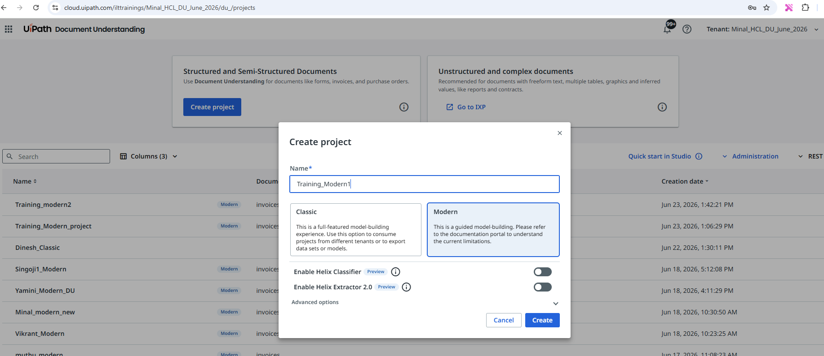
- Give name as “Training_Modern” and click save.
- Add the document type, choose “Invoices” and click Add.
2. Configure Extraction Fields
- Click on 3 dots and click on Document type manager.
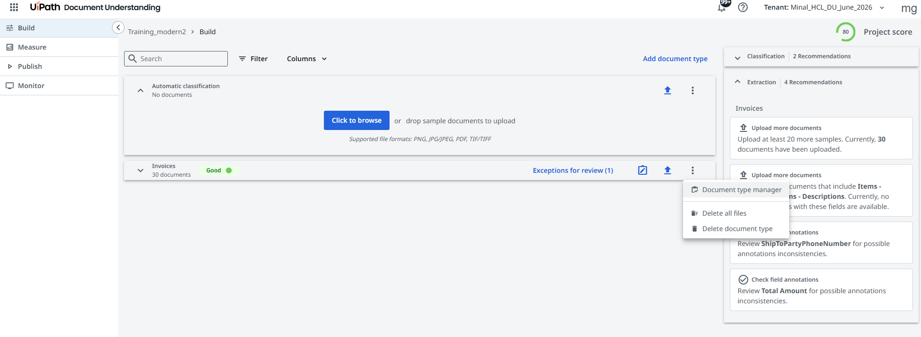
- Click on the Extraction Fields tab.
Keep these fields and remove all rest of the fields.
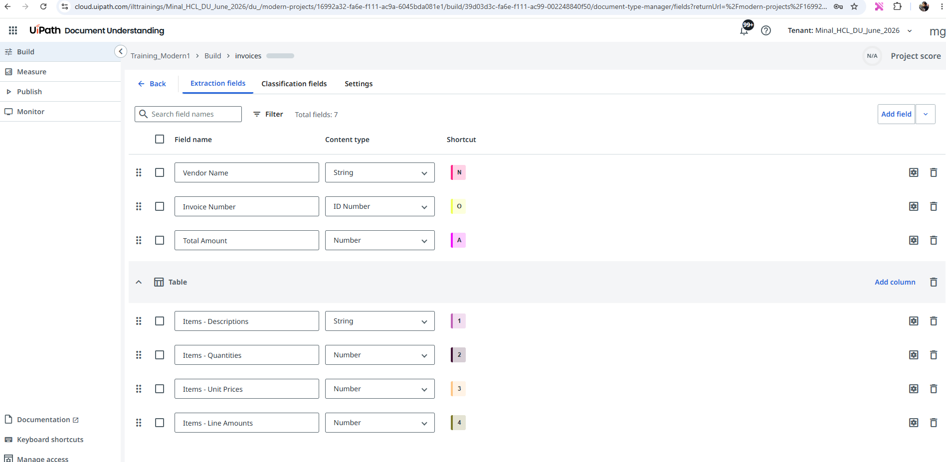
- Add a new Etraction field called “ShipToPartyPhoneNumber” of type “String”
3. Upload Sample Documents
- Navigate to the Build section.
- Upload sample invoice documents.
- Wait for the documents to be processed.
- Verify that all uploaded files are available for annotation.
4. Annotate Documents
- Open a sample invoice.
- Select a field from the Extraction Fields panel.
- Highlight the corresponding value on the invoice.
- Map:
  - ShipToPartyPhoneNumber
  - Vendor Name
  - Invoice Number
  - Total Amount
- Annotate table columns for line-item extraction if applicable.
- Repeat for all required fields.
5. Validate Annotations
- Review all highlighted fields.
- Ensure each field is mapped correctly.
- Check confidence scores and extraction quality.
- Save the annotations.
5. Check the measure section
- Go to metrics
- Ensure you have satisfactory accuracy percentage for each field.
6. Publish the Extraction Model
- Navigate to Publish.
- Click on create project version, choose the document type as “Invoices”, give a name and click on Create.
- Toggle the deployed button.
7. Create a Studio Automation
- Click on “Open UiPath Studio”.
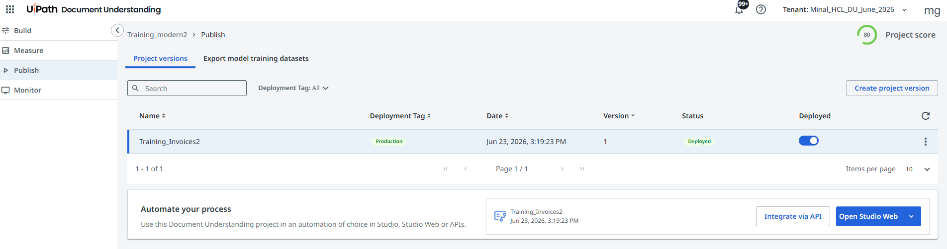
- This will open the automation in studio web in another tab.
- Run the studio web workflow and test it.
- Observe the execution logs.
- Verify extraction results.
- Confirm that invoice data is extracted successfully.

